## Mandatory Training 2025

### Safety and Security Training (30 minutes) – *Completed*

**Topics Covered:**

* **Life Saving Rules**: Understanding and adhering to non-negotiable safety requirements.
* **Physical Security**: Reviewing office security protocols and travel support for Nokia employees.
* **Health & Safety in Projects**: Best practices for health and safety in customer projects.
* **Incident Reporting**: Procedures for reporting health, safety, or security incidents.
* **Wellbeing**: Resources and support services for personal wellbeing and a healthy work environment.

**Additional Notes:**

* **Sitting Posture**: Maintain ergonomic posture while working.
* **Nokia SOS**: +44 207 365 9626
* **Nokia Concur**: Travel and expense management platform.
* **GSOC (Global Security Operations Center)**:
  + 📞 +1 469 661 3018
  + 📧 [security@nokia.com](mailto:security@nokia.com)

### Ethical Business Training (45 minutes) – *Completed*

### Information Security and Privacy Awareness (25 minutes)- Completed

## Nokia FlowOne Overview

**Course ID**: DO00647-K-2300

## Service Fulfilment

### Fider Introduction to X-FTTx

**Key Concepts:**

* **Optical Networks**
* **Optical Line Terminal (OLT)**
* **Optical Splitter**
* **Optical Network Terminal (ONT)**
* **FTTx**: Generic term for optical fiber broadband architecture
  + **GPON**: 2.5 Gbps
  + Variants:
    - Fiber to Node (FTTN)
    - Fiber to Cabinet (FTTC)
    - Fiber to Building (FTTB)
    - Fiber to Home (FTTH)
* ONT-ONT -> Splitter – (OLT -HIS (high speed internet)-VoIP (Voice over IP)-IPTV (TV over the internet)) central office – access network – transport network
* A triple play network is one which voice, video and data are provided in a single access subscription

### EX Flow one catalog driven fulfillment (CDFF) Solution

Triple-Play Solution – Key Requirements

* Product Catalog Management

- Easy to add new products

- Maintain existing products efficiently

* Unified Order Tracking

- Track all order processing in a single system

* Manual Task Support

- System should allow for manual interventions when needed

* Inventory System Integration

- Manage both physical and logical inventory

- Maintain subscriber profiles

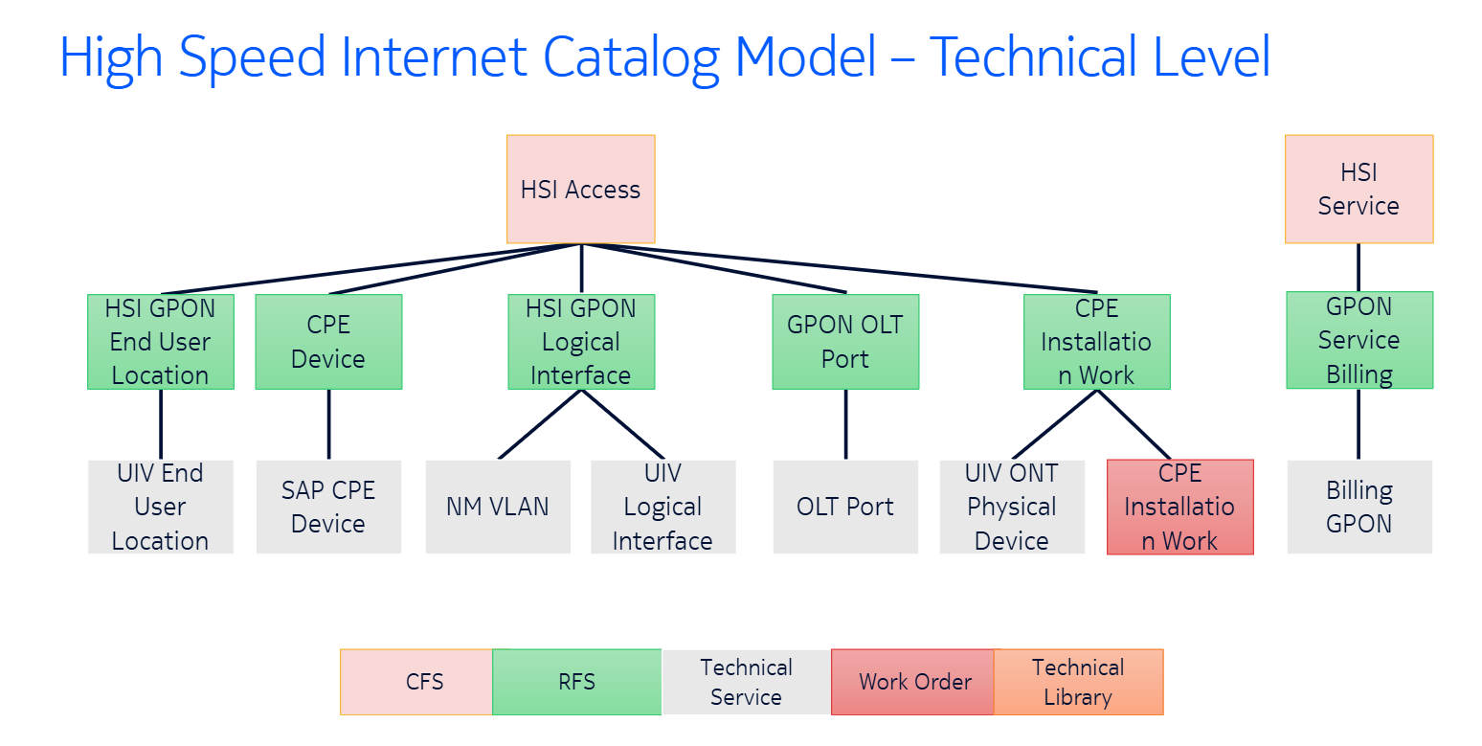

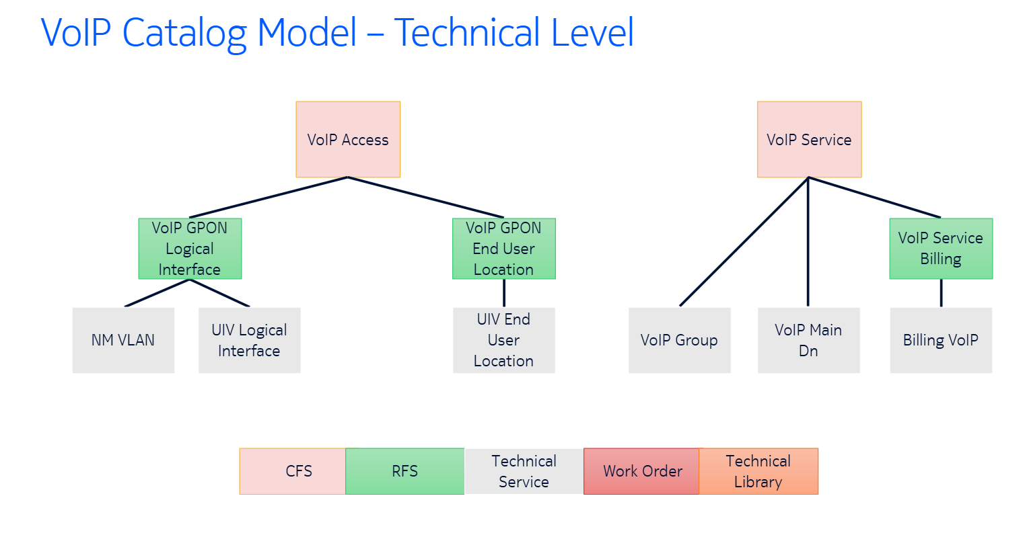

## Catalog-Driven Fulfillment

* Order entry
* Order Decomposition
* Provision and Install
* Completed order

## CDPA (Catalog driven Provisioning and Activation)

* Catalog: Defines how services are delivered to customers
* Provisioning and Activation: Process the order based on the catalog instructions
* Catalog concepts:
* CFS (Customer facing service)
* RFS (Resource facing service)
* Remote items
* Technical Services
* Technical library
* Work order
* Selection Group
* Must be embedded into another product or service
* CDPA Deployment
* Traditional
* Cloud – ready
* CDPA Deployed as VNFM (Virtualized network function manager)
* Cloud Band Application Manager (CBAM)
* UIV (Unified Inventory)
* Nokia Flow one
* Nokia Orchestration
* Nokia Assurance
* UIV Components
* RESTful API Layer
* Discovery and Reconciliation
* Neo4j Graph database
* UIV Components are deployed using CSPF (Common Software Foundation Platform)

## 

## Flow One Introduction to Catalog

**Course ID**: DO00545-K-2300

* Catalog Features
* SOAP-BASED APIs
* TECHNICAL CAPABILITIES
* CATALOG DESIGNER
* CATALOG MODELS
* LIFE – CYCLE MANAGEMENT
* 3RD PARTY SOURCING OF PRODUCTS
* PRODUCT RULES AND DEPENDENCIES
* PROCESS DESIGN
* Flow One Fulfillment
* Flow one fulfillment is a robust network service management platform for the end-to-end fulfillment process – from service order capture to service delivery
* Service model Structure
* Customer facing services – Resource facing services – Technical services
* Catalog service Items
* Technical service (TS): Specification of a network level capability
* Technical library (TL): It is used if there is data enrichment
* Work order (WO): A manual task
* Error Recovery
* Flow one catalog has seven default transactions
* Provide
* Amend
* Cease
* Create
* Modify
* Delete
* Display
* Flow one fulfillment request/task types
* Create
* Modify
* Delete
* Display
* Defined by selecting the undo transaction
* Undo = Rollback

## Flow One eLearning Subscription Curriculum

**Course ID**: DO00592-G-2100